Hybrid IT Services Inc.
Helping You to Manage Your Business the Better Way
928 S Terrace Rd, #104,
Tempe, AZ, 85281
Phone:
(480) 639 HITS
(480) 307-7328
Fax:
480-304-9054
info@hybriditservices.com
www.hybriditservices.com

Requirements Review
Version 1.4
For Unseen Seen

Following colors show the current status of a Project.
Incomplete
Partial Complete
Complete

Unseen & Seen.com
Concept of the Project:
Helping people reporting their personal belongings or items that have been lost in public areas or possible places where there could be a sign of getting found by someone who can deliver or return the item back to its original owner.
These possible audiences could be the following;
- People who were at their particular place where the item was reported to be lost. This includes a store, restaurant, park, malls, hotels, meeting place or someplace where the possibility can be addressed
- People living in close proximity of the region or place where item could have been left over without attention from the owner of the item. This means that potential audience can be targeted with specific radius miles potentially with in particular zip code and targeted place.

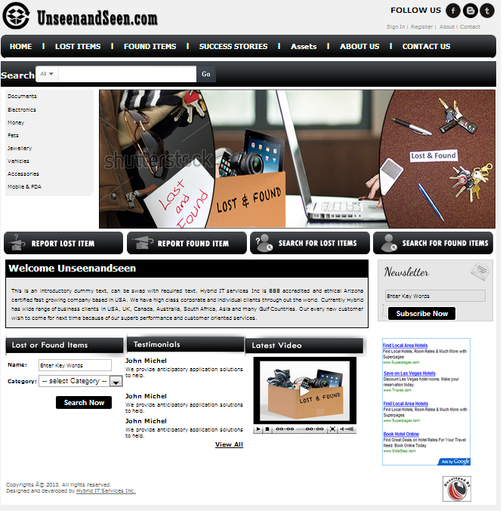

- Registration Process

  - Personal Details
    - First Name
    - Last Name
    - Address (optional)
    - Phone #
  - Account Details
    - Username
    - Password
    - Confirm password
  - How you hear about us? (Dropdown)
    - Search Engine
    - Facebook
    - Twitter
    - LinkedIn
    - e-mail
    - Friend
    - Other
  - CAPTCHA
  - Acceptance of the Terms & Conditions
  - Confirmation Page with message to check and authenticate email address
  - E-Mail Verification and Login

- User Work Space

User work space will comprise of the following;
      - Asset Database
      - Reported Lost Items
      - Area based NEW Requests
      - Account Settings
      - Notifications / Message Board
      - Items Found

- Approaching possible Audience:
Possible audience could be approached by several different ways based on the interest, location, profession and other possibilities;
  - E-Mail notification to the people living in particular zip code.

  - iPhone Android Application push notification for new request to the people who are living in lose proximity future development can target the REAL TIME reporting of the items at particular place and indication to the people who are at the place in real time LIVE manner.

- Personal Items / Assets Database Build:

People will be able to store their personal belonging in the form of categories and sub categories. These categories need to be BUILT dynamically from the backend administrator and will be displayed like being displayed in www.amazon.com

The normal attributes defined for registering the product are the following;

  - Item Details / Asset Registration :
    - Questioner:
    - Will you want to get offer for similar item reported for sale
    - Selection of the Primary Category – Default Selection will be provided
    - Selection of the Secondary Category- Default Selection will be provided
    - Details
    - Recognitions / Identification Mark / Distinguishing Feature
    - Pictures if Available OR Select Default Graphic

- Reporting a Lost Item

This process will comprise on 4 STEPS;
  - Contact Details furnished from User Profile (ref )
  - Item Details – Selected from Asset Database (ref 2.1)

  - Geographic location where item was lost
    - Show Categories to choose from. List of Location Category will be provided
    - Enter name of the Place OR Enter complete Address
      - Enter Zip code
      - System will furnish places from the zip code using Google Maps

  - Listing Details :
      - Period this Add will be posted for. Select End Date from Calendar
      - Request INSTANT posting & Notify current visitors? Yes / No
      - Request users living in Close Proximity.
            - Select Miles Radius from the Map.
OR
            - Post in Particular Zip code

- Important Features
  - Control of PORN Images
  - Control of FLITY words in posts

- Search Item to be Found

  - Search Item Title & Zip code Box
  - Results will be furnished like www.amazon.com or May be better. We can use TWO Columns. Whatever best possibly appealing

- Administrator Panel

  - CMS
  - User Database with OPTION to view the following;
    - User Profile
      - Normal Details
      - Especially eMail Address
      - Registered Date
      - Last Logged in
    - Total # of Asset Inventory
    - Total # of Items Listed as Lost Items
    - Total # of Items Listed as FOUND
    - Total # of Lost Items available for OPEN request for User Location

  - Reports
    - Filters
      - Dates
      - User First & Last Name
      - States (Dropdown)
      - City (Dropdown) & State(Dropdown)
      - Listed Lost Items
      - Founded Items
    - Items Listed in Complete Solution as Available Lost Items in Grace Period with Total
    - Items Listed in Complete Solutions which have crossed Grace Period with Total #
    - Items Listed as Complete Inventory in System from All Users with Total #

  - Advertisement Module
    - www.almashreqonline.com
There is no space of Advertisement module at the top right of the page so this module can only be fit at right bottom of the page and it will not in the form of sliding as this module is working in almashreqonline.com

  - Settings

  - eMail List of All Users

  - Statistics on DASHBOARD

    - Total of Users
    - Total Number of Listed Reported Lost Times Dates
      - Active
      - Expired
    - Total number of request of founding items available to total invited number of users
    - Total number of new lost items reported in last 24 hours Clickable to view
    - Total number of Active Advertisements
    - Total number of Advertisements done till date
    - # Advertisements expiring in next 7 days
    - # of Current users who are online – Clickable to view
    - How many responses for all options of How you hear about us, just the numbers here.
- Testimonials
A person write a statement extolling the virtue of some product.
- Latest Video
This session shows a Video for the users of the website from administrator.

